Choco Dock
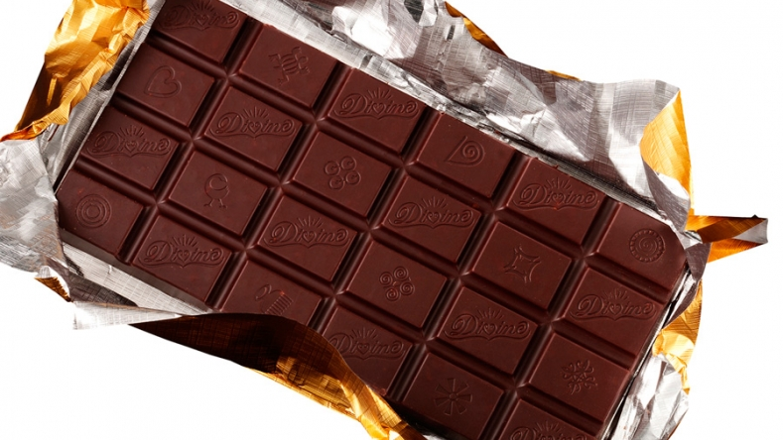Ever dreamed of your favourite chocolate treat? Well why don’t you try choco dock , all we’ve heard so far is ‘yum yum yum
.large……………………………………£2
.medium………………………………………..£1:50
.small ………………………………………………….£1
So what are you waiting for come now!

