Quick Art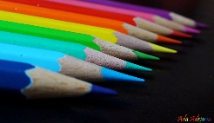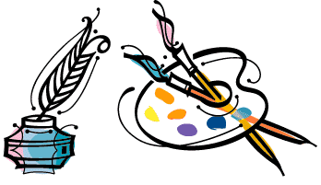

At Quick Art we will inspire you to have more interest in art for £1.00 from 1.30pm till 2.00pm!! You will ask Lully, Brooke and Chana to give us something to draw and we will creatively draw in a small amount of time.

We will really appreciate it if you would come to visit us. Thursday 3rd November 2016.

